LAB 1:

RESISTANCE, VOLTAGE AND CURRENT MEASUREMENTS

Class: EEE 117 Lab

Professor: Sergio Aguilar Rudametkin

Author: Ramyasri Singamsetty

September 5, 2018

* 1. **INTRODUCTION**

This lab utilizes several digital and analog instruments that can be used to measure resistance, voltage, and current. These electronic instruments consist of the Digital Multi-meter and oscilloscope. One of the instruments this lab requires is the Digital Multi-meter. A DMM is a measuring instrument that can be used to measure all of the parameters listed above. This lab also requires the use of an oscilloscope which is an instrument that measures and displays voltage signals as waveforms to a digital screen. The information gathered from both the DMM and oscilloscope, allow the circuit built to be analyzed as circuit analysis is one of the main focuses of this lab. The three circuits, required to be constructed by the lab assignment, deal with voltage, resistance, and current calculations.

* 1. **PURPOSE**

The purpose of this lab is to learn and understand how to use the DMM and oscilloscope in relation to building different circuits that deal with three electrical circuit elements: voltage, current, and resistance. One of the main functions of this lab requires that we understand how to measure voltage, current, and resistance values in two different settings on the oscilloscope(X1 and X10) in-line with the DMM. After recording measurements for the three previously mentioned values in three given circuits, we need to understand how to perform calculations with the measured values. These calculations include the main elements of circuit analysis such as Kirchoff’s Current and Voltage Law and Voltage and Current Division equations. The results of these calculations will then be compared to our measured values to see how close hand versus equipment measurements are.

* 1. **PROCEDURE**

**Part I. Resistance Measurements**

For this portion of the lab we measured solely resistance values of the circuit provided. The two resistors are called R1 and R2, which are in series, and have resistance values of 100 KOhms and 300 KOhms respectively. The voltage of the circuit is 2.0v. The given circuit is a voltage divider. A voltage divider consists of two resistors in series and a voltage. The divider essentially divides the input voltage as a fraction of the voltage. We measured these values using the digital multi-meter and the oscilloscope.

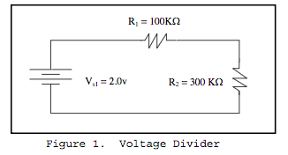

The given and measured valued can be seen in Table 1 below.

Table 1: Specified vs. Measured Resistance Values

|  |  |  |
| --- | --- | --- |
| Resistor | Specified Resistance | Measured Values |
| R1 | 100 KOhms | 100.273 KOhms |
| R2 | 300 KOhms | 298.86 KOhms |

After measuring the R1 and R2 values, we had to measure values using the oscilloscope. The oscilloscope we used has two probes called X1 and X10 which can be used to check resistance, current and voltage by using the digital multimeter. We measured the two resistances using the X1 and X10 probes separately and compared the two measurements.

Table 2: Resistance measurements of resistors using X1 and X10 probes.

|  |  |  |
| --- | --- | --- |
| Resistor | Channel #1 of Oscilloscope w/ X1 probe | Channel #1 of Oscilloscope w/ X10 probe |
| R1 | 1.002 MOhms | 1.002 MOhms |
| R2 | 9.99 MOhms | 9.981 MOhms |

The third main measurement involving resistances involved measuring the resistances with the oscilloscope turned on and off.

|  |  |  |
| --- | --- | --- |
| Resistor | Input Resistance: Oscilloscope On | Input Resistance: Oscilloscope Off |
| R1 | X1: 1.197 MOhms  X10: 10.193 MOhms | X1 & X10: 0 Ohms |
| R2 | X1: 1.198 MOhms  X10: 10.182 MOhms | X1 & X10: 0 Ohms |

**Part II. Voltage Measurements**

1. **Unloaded Voltage Readings**

For this portion of the lab, we measured the voltages running through the individual resistors(as shown in Figure 1) using the digital multimeter. We recognized that the circuit is a voltage divider and compared the measured values to the hand calculated values computed by using the Kirchhoff’s Voltage Law.

*Measurements of an input voltage and two resistor voltages.*

Vinput  = 1.999 Volts VR1  = 0.498 Volts VR2  = 1.498 Volts

*Hand Calculations using Kirchhoff’s Voltage Law: Part A Unloaded Voltage Readings*

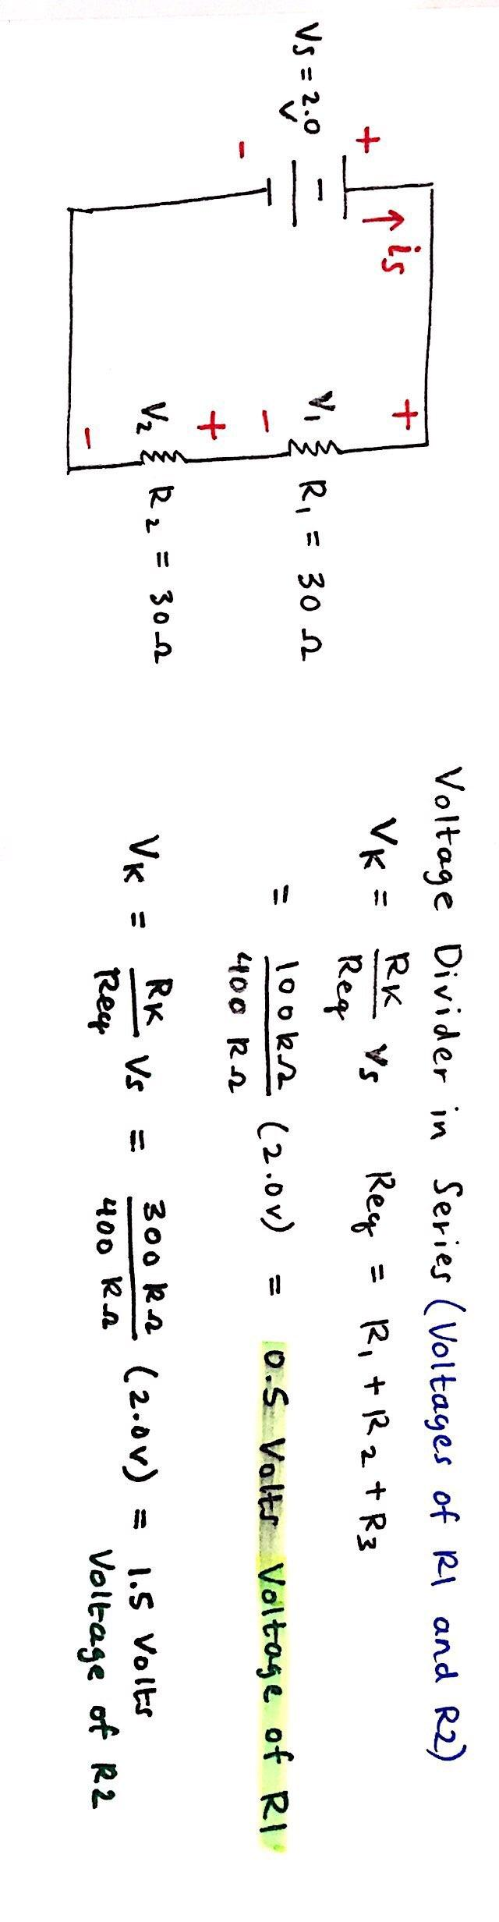

The measured voltage measurements in comparison to the hand calculated voltage measurements are very close to each other.

1. **Loaded Voltage Readings (X1 Probe)**

Part B is similar to Part A in the sense that the voltages of the input and the resistors need to be measured. The difference here is that all of these voltages will be measured through the X1 probe on the oscilloscope. Part B uses the same circuit as part one but contains the probe.

*Measurements of an input voltage and two resistor voltages with X1 probe added to R2.*

Vinput  = 1.99 Volts VR1  = 0.463 Volts V R2  = 1.382 Volts

*Hand Calculations using Kirchhoff’s Voltage Law: Loaded ( X1 Probe)*

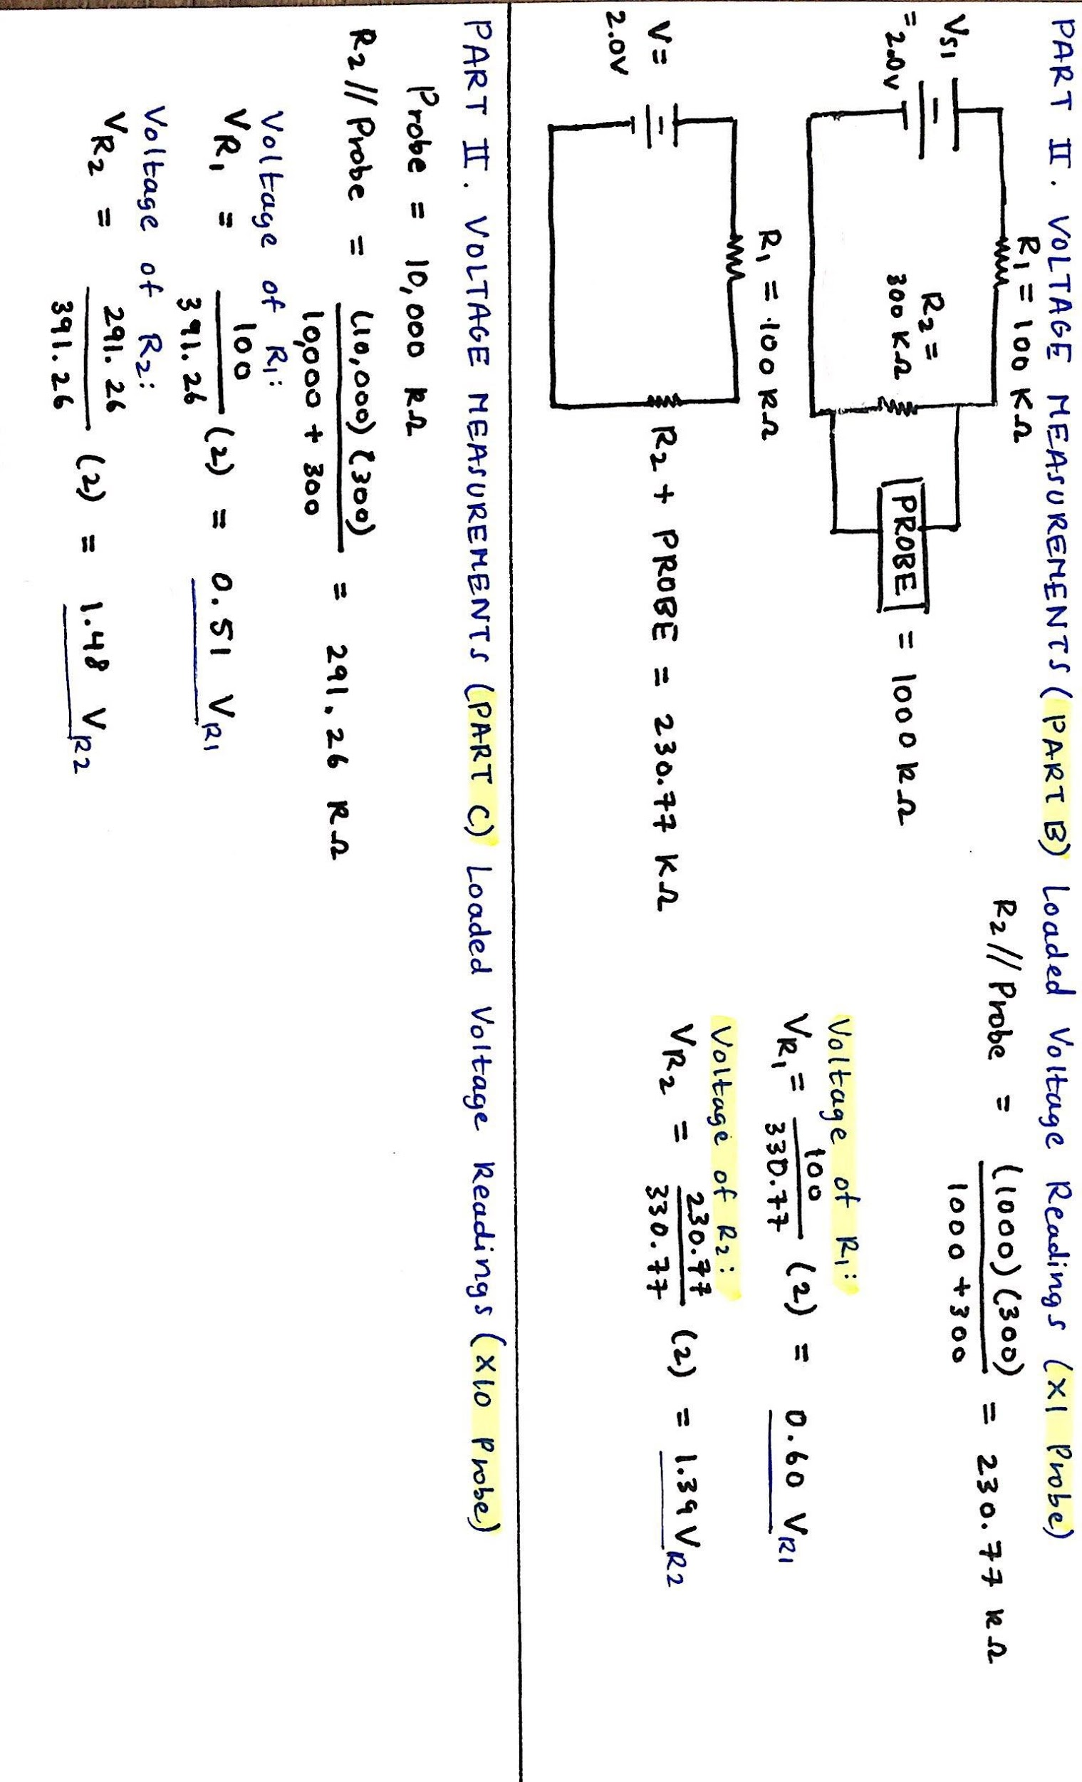

1. **Loaded Voltage Readings (X10 Probe)**

Part C is similar to Part B in the sense that the voltages of the input and the resistors need to be measured. The difference here is that all of these voltages will be measured through the X10 probe on the oscilloscope.

*Measurements of an input voltage and two resistor voltages with X10 probe added to R2.*

Vinput  = 1.99 Volts VR1  = 0.495 Volts VR2  = 1.475 Volts

*Hand Calculations using Kirchhoff’s Voltage Law: Loaded ( X10 Probe)*



**Part III. Current Measurements**

This portion of the lab works with measuring current values and using a different circuit (Figure 3 below) that represents a current divider.

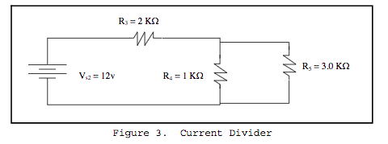

Current measurements of all 3 resistors in Figure 3.

IR3  = 4.358 mA IR4  = 3.267 mA IR5  = 1.091 mA

To ensure that these measurements are correctly measured by the ammeter, we performed hand calculations using Kirchhoff’s Current law to compare the measured and calculated values.

*Hand Calculations using Kirchhoff’s Current Law*

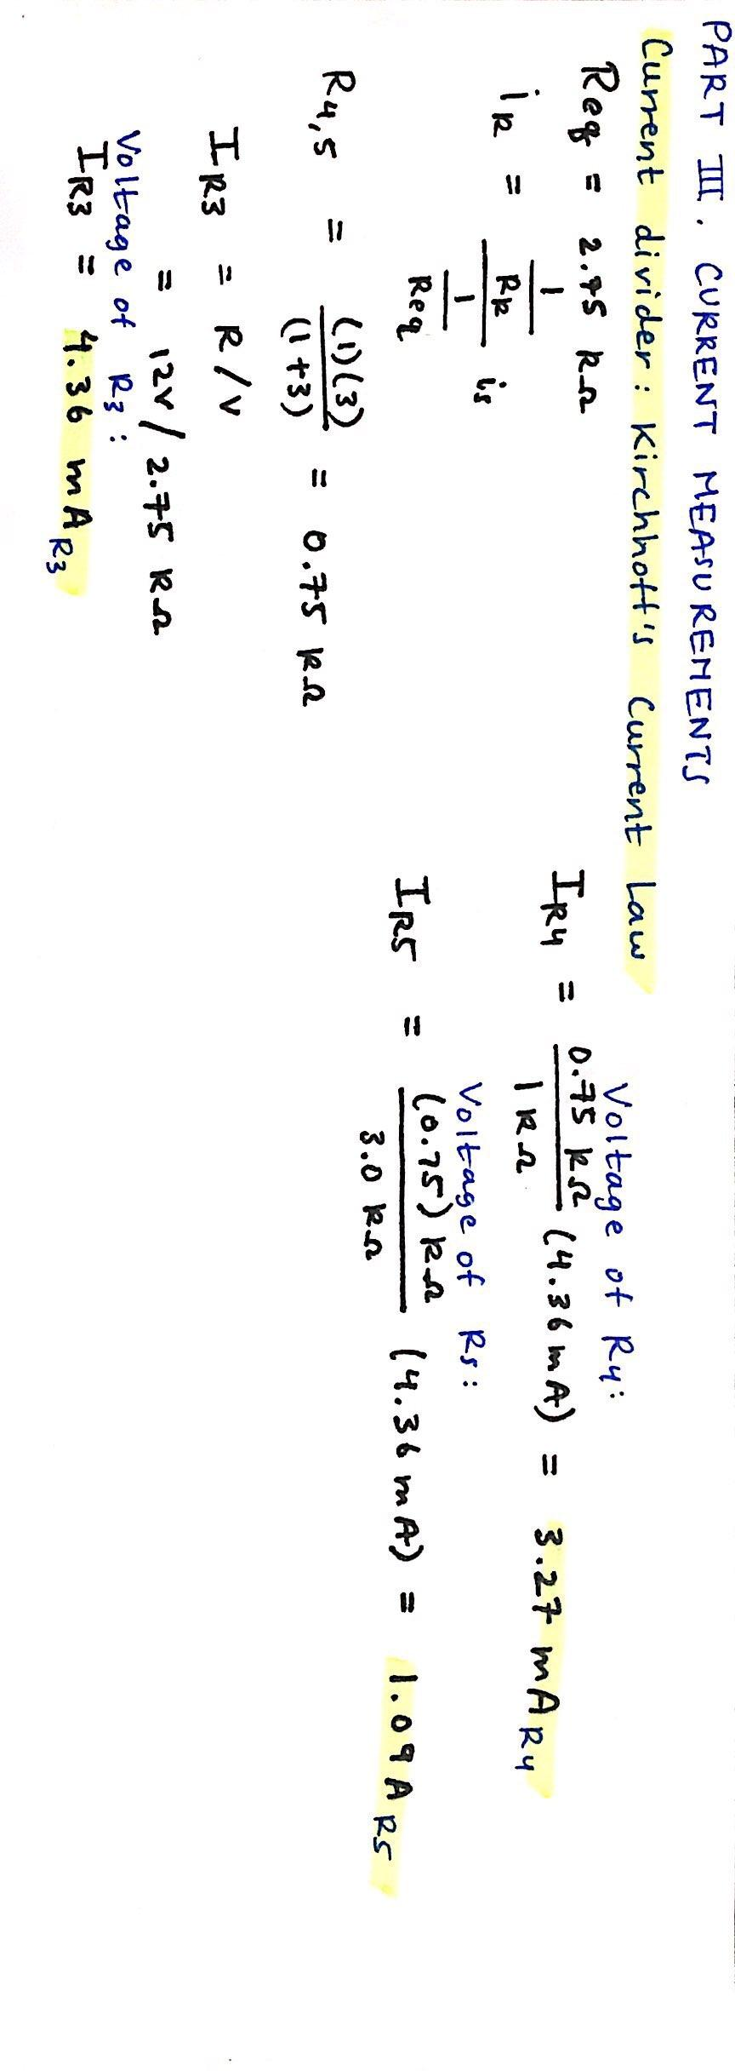

The measured and calculated values of the currents running through the three resistors are close in value so our voltages were measured correctly.

**Discussion Topics**

1. During the lab we used Kirchhoff’s Voltage and Current laws to calculate the voltage and current in the given current divider/voltage divider circuits. Kirchhoff’s current/voltage laws were verified in the case of lab because the measured values matched the calculated values.
2. Kirchhoff’s current and voltage laws were verified because our measured values matched the calculated values of the voltage and current that we found.
3. The oscilloscope probes met the advertised specifications because in the cases that we measured the voltage values in Part 2 we used the X1 and X10 probes. The X10 probe measurements were larger than the X1 measurements, this is due to the amplification of the measurement.
4. The expected voltage in the circuit is 2.00 volts and when we measured the input voltage we obtained a value of 1.99 volts each time. So, the input voltage matched the source digital display.
5. The values of the resistors were fairly close to the color code values of the resistors because the expected and calculated values are very close.
6. In order to disturb the circuit as little as possible, I would use the X1 probe because it does not amplify the circuit values as much as the X10 probe would.

**Conclusion**

The overall lessons that we learned from this lab consist of working with circuit analysis, building circuits, and working with Kirchhoff’s Current and Voltage laws. In terms of circuit analysis, we had to analyze that the circuits were voltage and current dividers, respectively.

I found that building circuits was the most challenging portion of the lab because translating a schematic to a physical circuit was difficult. Another aspect of this lab that was very beneficial was learning how to use the laboratory equipment using the digital multimeter, ammeter, and the oscilloscope. Thorough hand calculations and measurements using the previously listed measurements helped us to perform a proper analysis of our data.